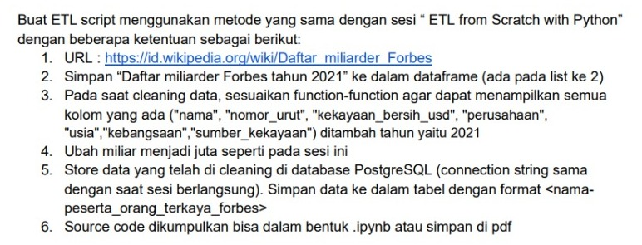Homework Session 18th

**Link GIT HUB 🡺 https://github.com/tianjol/ds_hw_ses_18_etl_scrath.git**

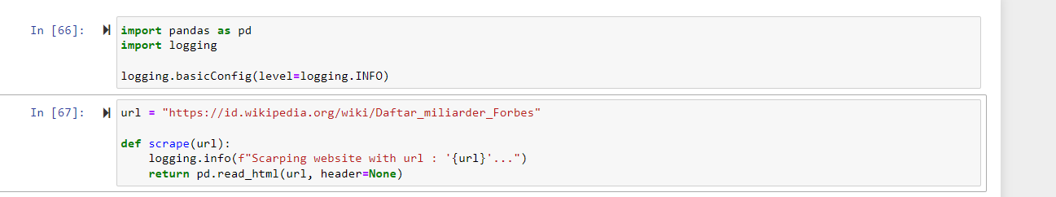1.

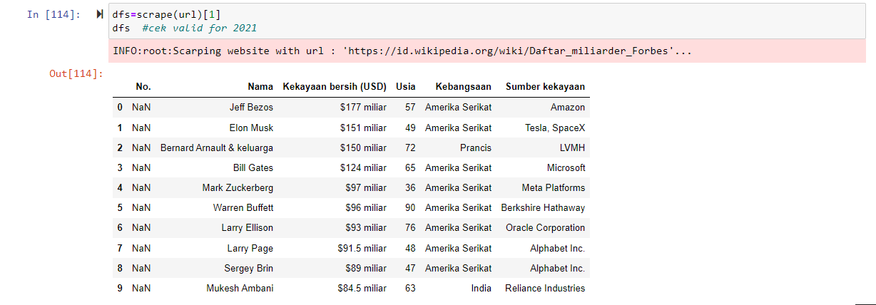2.

3. add new column => no_urut

